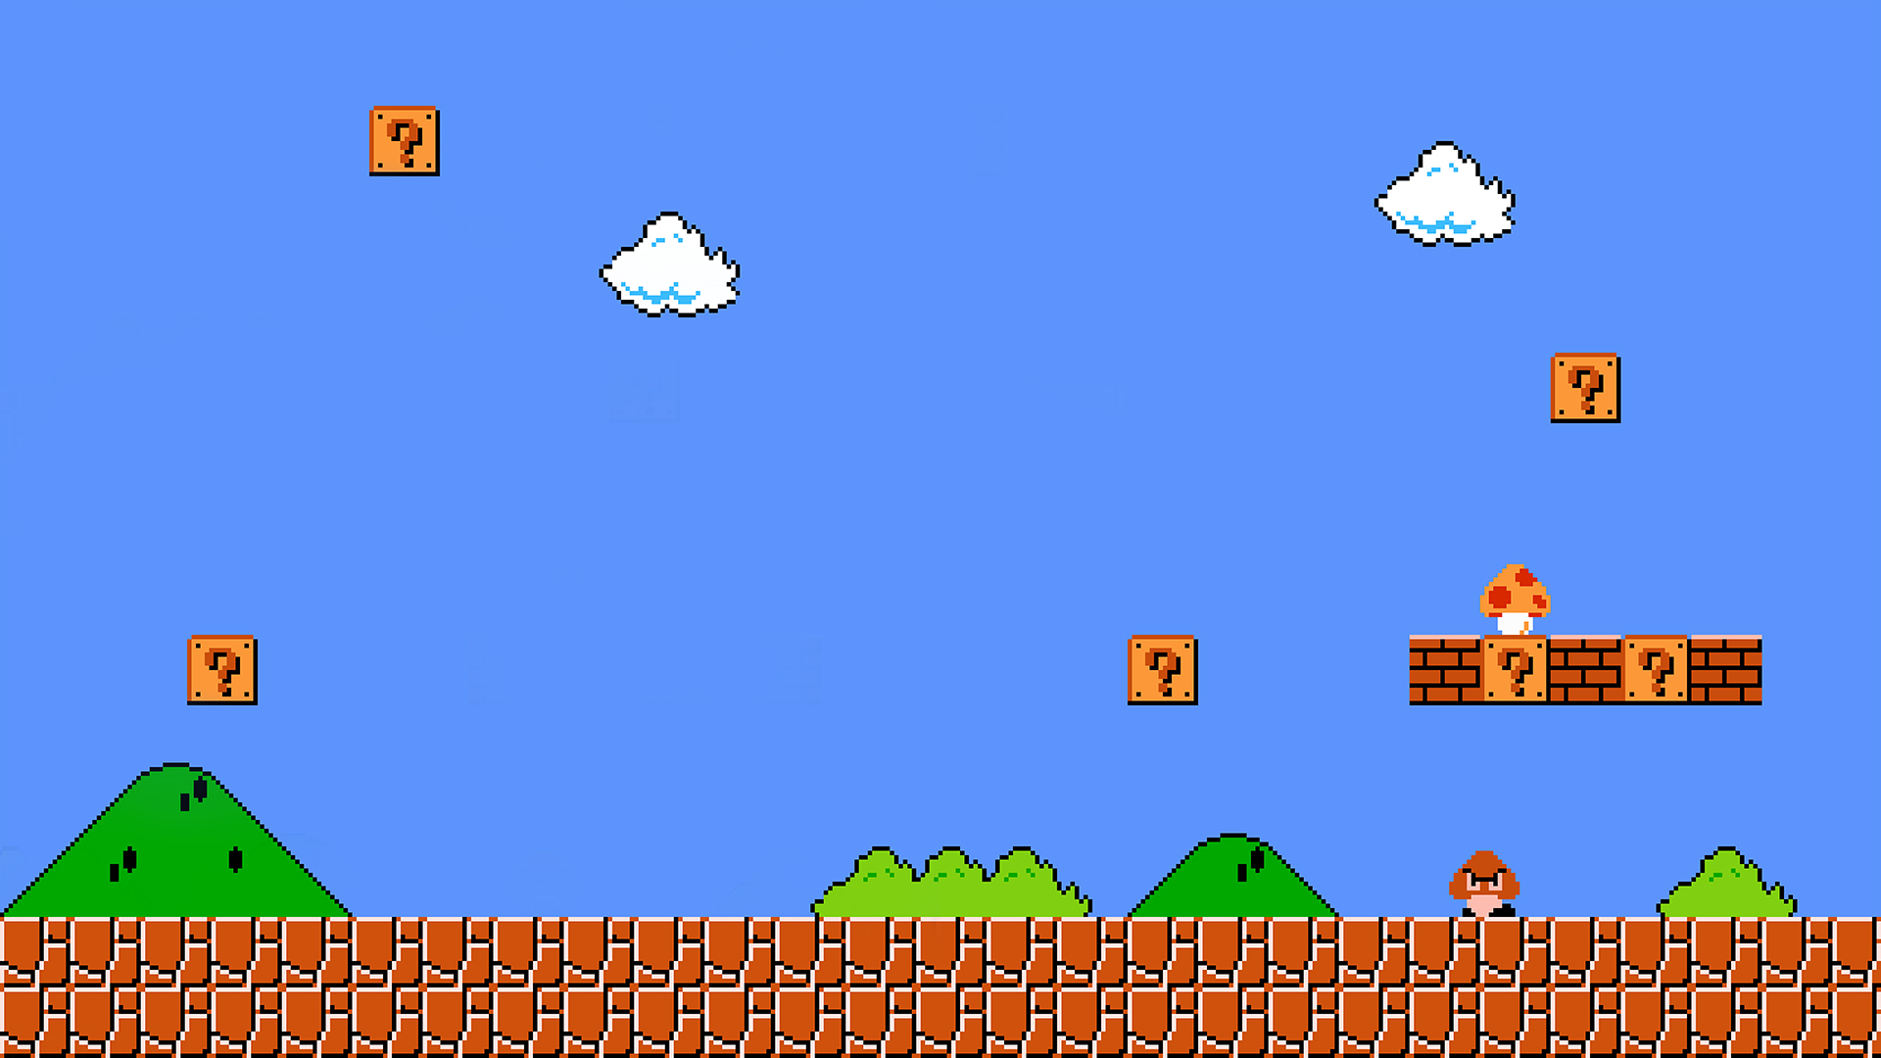

**OLDSCHOOL!!**

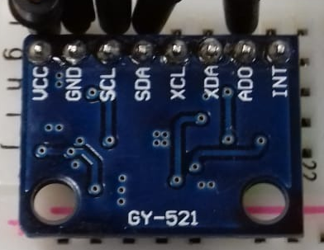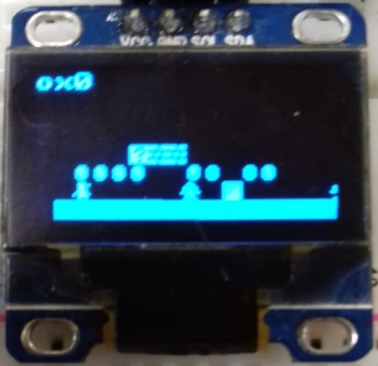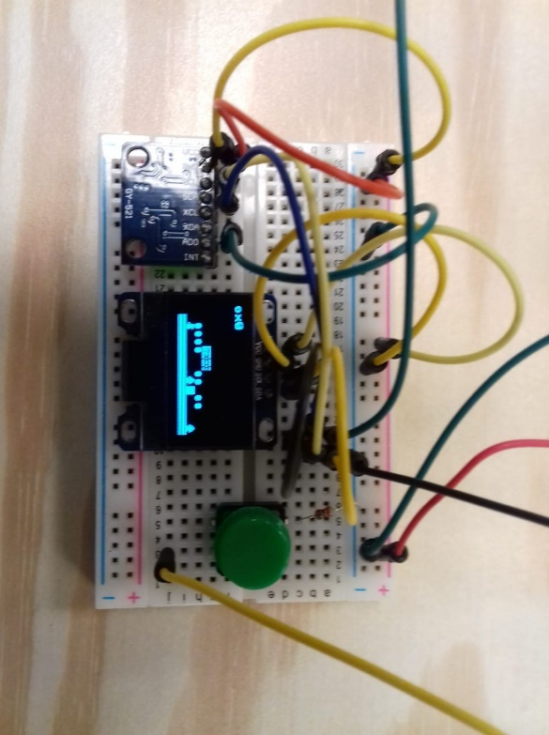

**Break blocks!**

**Defeat enemies!**

**Collect coins!**

**MPU-6050 Gyroscope / Accelerometer**

**OLED 128 x 64**

**Super Marius Bros**